# FINAL PROJECT REPORT

# WINE QUALITY PREDICTION

The data was downloaded from UCI Machine Learning Repository. This dataset consists of red and white variants of the Portuguese "Vinho Verde" wine.The dataset describes the amount of various chemicals present in wine and their effect on it's quality. The datasets can be viewed as classification or regression tasks. The classes are ordered and not balanced (e.g. there are much more normal wines than excellent or poor ones).Our task is to predict the quality of wine using the given data.

What are the factors that affect the quality of wine?

Wine quality depends on a lot of factors like alcohol content,presence of sulphates,its pH values etc. The taste,smell and potency of the wine is defined by its chemical ingredients and its percentages in wines.

We will perform following tasks in our notebook:

1. Data Exploration (Understanding the dataset)
2. Data Wrangling (Data cleaning and Data Manipulation)
3. Data visualization
4. Data Exploratory Analysis
5. Analysis of quality with other factors (correlation)
6. Data Modeling (Machine Learning Models)
7. Building a classification
8. Predict the outcome
9. Calculating the accuracy score
10. Findings and Results

# This Python 3 environment comes with many helpful analytics libraries installed  
  
# importing libraries for data analysis and data manipulation  
  
import numpy as np # linear algebra  
import pandas as pd # data processing, CSV file I/O (e.g. pd.read_csv)  
  
# loading the libraries for creating the plot  
  
import matplotlib.pyplot as plt  
import seaborn as sb  
import math

# import the dataset from our local machine  
Winedata = pd.read_csv("C:\\Users\\nidhi\\Downloads\\winequalityN.csv")  
Winedata

type fixed acidity volatile acidity citric acid residual sugar \  
0 white 7.0 0.270 0.36 20.7   
1 white 6.3 0.300 0.34 1.6   
2 white 8.1 0.280 0.40 6.9   
3 white 7.2 0.230 0.32 8.5   
4 white 7.2 0.230 0.32 8.5   
... ... ... ... ... ...   
6492 red 6.2 0.600 0.08 2.0   
6493 red 5.9 0.550 0.10 2.2   
6494 red 6.3 0.510 0.13 2.3   
6495 red 5.9 0.645 0.12 2.0   
6496 red 6.0 0.310 0.47 3.6   
  
 chlorides free sulfur dioxide total sulfur dioxide density pH \  
0 0.045 45.0 170.0 1.00100 3.00   
1 0.049 14.0 132.0 0.99400 3.30   
2 0.050 30.0 97.0 0.99510 3.26   
3 0.058 47.0 186.0 0.99560 3.19   
4 0.058 47.0 186.0 0.99560 3.19   
... ... ... ... ... ...   
6492 0.090 32.0 44.0 0.99490 3.45   
6493 0.062 39.0 51.0 0.99512 3.52   
6494 0.076 29.0 40.0 0.99574 3.42   
6495 0.075 32.0 44.0 0.99547 3.57   
6496 0.067 18.0 42.0 0.99549 3.39   
  
 sulphates alcohol quality   
0 0.45 8.8 6   
1 0.49 9.5 6   
2 0.44 10.1 6   
3 0.40 9.9 6   
4 0.40 9.9 6   
... ... ... ...   
6492 0.58 10.5 5   
6493 NaN 11.2 6   
6494 0.75 11.0 6   
6495 0.71 10.2 5   
6496 0.66 11.0 6   
  
[6497 rows x 13 columns]

# to see the number of rows and columns in our dataset  
Winedata.shape

(6497, 13)

Winedata.columns

Index(['type', 'fixed acidity', 'volatile acidity', 'citric acid',  
 'residual sugar', 'chlorides', 'free sulfur dioxide',  
 'total sulfur dioxide', 'density', 'pH', 'sulphates', 'alcohol',  
 'quality'],  
 dtype='object')

Understanding the wine data columns

1. fixed acidity most acids involved with wine or fixed or nonvolatile (do not evaporate readily)
2. volatile acidity the amount of acetic acid in wine, which at too high of levels can lead to an unpleasant, vinegar taste
3. citric acid found in small quantities, citric acid can add ‘freshness’ and flavor to wines
4. residual sugar the amount of sugar remaining after fermentation stops, it’s rare to find wines with less than 1 gram/liter and wines with greater than 45 grams/liter are considered sweet
5. chlorides the amount of salt in the wine
6. free sulfur dioxide the free form of SO2 exists in equilibrium between molecular SO2 (as a dissolved gas) and bisul-fite ion; it prevents microbial growth and the oxidation of wine
7. total sulfur dioxide amount of free and bound forms of S02; in low concentrations, SO2 is mostly undetectable in wine, but at free SO2 concentrations over 50 ppm, SO2 becomes evident in the nose and taste of wine
8. density the density of water is close to that of water depending on the percent alcohol and sugar con-tent
9. pH describes how acidic or basic a wine is on a scale from 0 (very acidic) to 14 (very basic); most wines are between 3–4 on the pH scale
10. sulphates a wine additive which can contribute to sulfur dioxide gas (S02) levels, which acts as an antimicrobial and antioxidant
11. alcohol the percent alcohol content of the wine
12. quality output variable (based on sensory data, score between 0 and 10)
13. type This column will show the type of the wine whether it's a red wine or white wine

# to view any random sample of 8 rows  
Winedata.sample(8)

type fixed acidity volatile acidity citric acid residual sugar \  
1960 white 8.5 0.17 0.31 1.0   
1590 white 7.9 0.14 0.74 1.2   
4728 white 7.2 0.21 0.31 10.5   
5998 red 8.4 0.34 0.42 2.1   
742 white 7.0 0.20 0.37 2.0   
2458 white 7.8 0.32 0.33 10.4   
3439 white 6.7 0.40 0.22 8.8   
6027 red 10.5 0.43 0.35 3.3   
  
 chlorides free sulfur dioxide total sulfur dioxide density pH \  
1960 0.024 13.0 91.0 0.99300 2.79   
1590 0.028 30.0 165.0 0.99100 3.08   
4728 0.035 36.0 122.0 0.99478 3.12   
5998 0.072 23.0 36.0 0.99392 3.11   
742 0.030 26.0 136.0 0.99320 3.28   
2458 0.031 47.0 194.0 0.99692 3.07   
3439 0.052 24.0 113.0 0.99576 3.22   
6027 0.092 24.0 70.0 0.99798 3.21   
  
 sulphates alcohol quality   
1960 0.37 10.1 5   
1590 0.82 12.3 6   
4728 0.40 10.6 6   
5998 0.78 12.4 6   
742 0.61 10.2 6   
2458 0.58 9.6 6   
3439 0.45 9.4 5   
6027 0.69 10.5 6

# let us try to see the first 5 lines of our data  
Winedata.head()

type fixed acidity volatile acidity citric acid residual sugar \  
0 white 7.0 0.27 0.36 20.7   
1 white 6.3 0.30 0.34 1.6   
2 white 8.1 0.28 0.40 6.9   
3 white 7.2 0.23 0.32 8.5   
4 white 7.2 0.23 0.32 8.5   
  
 chlorides free sulfur dioxide total sulfur dioxide density pH \  
0 0.045 45.0 170.0 1.0010 3.00   
1 0.049 14.0 132.0 0.9940 3.30   
2 0.050 30.0 97.0 0.9951 3.26   
3 0.058 47.0 186.0 0.9956 3.19   
4 0.058 47.0 186.0 0.9956 3.19   
  
 sulphates alcohol quality   
0 0.45 8.8 6   
1 0.49 9.5 6   
2 0.44 10.1 6   
3 0.40 9.9 6   
4 0.40 9.9 6

# to see the descriptive statistics  
Winedata.describe()

fixed acidity volatile acidity citric acid residual sugar \  
count 6487.000000 6489.000000 6494.000000 6495.000000   
mean 7.216579 0.339691 0.318722 5.444326   
std 1.296750 0.164649 0.145265 4.758125   
min 3.800000 0.080000 0.000000 0.600000   
25% 6.400000 0.230000 0.250000 1.800000   
50% 7.000000 0.290000 0.310000 3.000000   
75% 7.700000 0.400000 0.390000 8.100000   
max 15.900000 1.580000 1.660000 65.800000   
  
 chlorides free sulfur dioxide total sulfur dioxide density \  
count 6495.000000 6497.000000 6497.000000 6497.000000   
mean 0.056042 30.525319 115.744574 0.994697   
std 0.035036 17.749400 56.521855 0.002999   
min 0.009000 1.000000 6.000000 0.987110   
25% 0.038000 17.000000 77.000000 0.992340   
50% 0.047000 29.000000 118.000000 0.994890   
75% 0.065000 41.000000 156.000000 0.996990   
max 0.611000 289.000000 440.000000 1.038980   
  
 pH sulphates alcohol quality   
count 6488.000000 6493.000000 6497.000000 6497.000000   
mean 3.218395 0.531215 10.491801 5.818378   
std 0.160748 0.148814 1.192712 0.873255   
min 2.720000 0.220000 8.000000 3.000000   
25% 3.110000 0.430000 9.500000 5.000000   
50% 3.210000 0.510000 10.300000 6.000000   
75% 3.320000 0.600000 11.300000 6.000000   
max 4.010000 2.000000 14.900000 9.000000

# let us check the data types of all the variables to get a better understanding of our data  
Winedata.info()

<class 'pandas.core.frame.DataFrame'>  
RangeIndex: 6497 entries, 0 to 6496  
Data columns (total 13 columns):  
 # Column Non-Null Count Dtype   
--- ------ -------------- -----   
 0 type 6497 non-null object   
 1 fixed acidity 6487 non-null float64  
 2 volatile acidity 6489 non-null float64  
 3 citric acid 6494 non-null float64  
 4 residual sugar 6495 non-null float64  
 5 chlorides 6495 non-null float64  
 6 free sulfur dioxide 6497 non-null float64  
 7 total sulfur dioxide 6497 non-null float64  
 8 density 6497 non-null float64  
 9 pH 6488 non-null float64  
 10 sulphates 6493 non-null float64  
 11 alcohol 6497 non-null float64  
 12 quality 6497 non-null int64   
dtypes: float64(11), int64(1), object(1)  
memory usage: 660.0+ KB

# to check skewness  
Winedata.skew()

fixed acidity 1.722805  
volatile acidity 1.495512  
citric acid 0.473032  
residual sugar 1.435000  
chlorides 5.399849  
free sulfur dioxide 1.220066  
total sulfur dioxide -0.001177  
density 0.503602  
pH 0.386966  
sulphates 1.798467  
alcohol 0.565718  
quality 0.189623  
dtype: float64

Winedata.hist(figsize=(15,15), layout=(4,4), bins=20)

array([[<AxesSubplot:title={'center':'fixed acidity'}>,  
 <AxesSubplot:title={'center':'volatile acidity'}>,  
 <AxesSubplot:title={'center':'citric acid'}>,  
 <AxesSubplot:title={'center':'residual sugar'}>],  
 [<AxesSubplot:title={'center':'chlorides'}>,  
 <AxesSubplot:title={'center':'free sulfur dioxide'}>,  
 <AxesSubplot:title={'center':'total sulfur dioxide'}>,  
 <AxesSubplot:title={'center':'density'}>],  
 [<AxesSubplot:title={'center':'pH'}>,  
 <AxesSubplot:title={'center':'sulphates'}>,  
 <AxesSubplot:title={'center':'alcohol'}>,  
 <AxesSubplot:title={'center':'quality'}>],  
 [<AxesSubplot:>, <AxesSubplot:>, <AxesSubplot:>, <AxesSubplot:>]],  
 dtype=object)

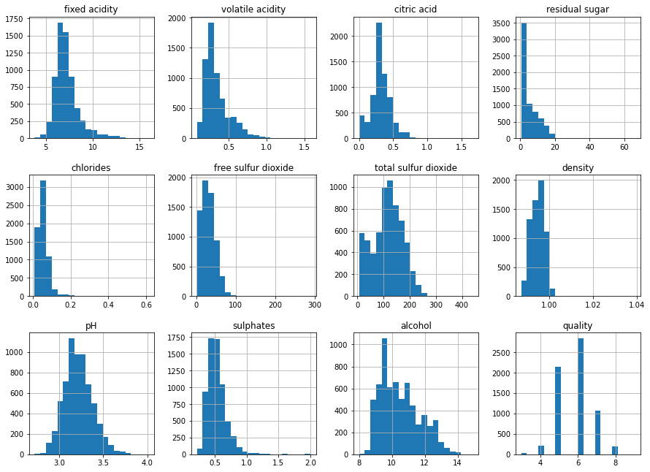

**Observation** from histogram:

1. “fixed.acidity” is a measure of inside liquid concentration. The histogram a right-skewed distributed with some outliers located at right side. The most frequent values are between 7-8.
2. “volatile.acidity” is measure of acidity above-surface of liquid. The histogram is right-skewed distributed with some outliers located at right side. The most frequent values are between 0.4-0.6.
3. “citric.acid” is right-skewed distributed with some outliers located at very right side. The most frequent values 0. It’s also interesting a lot of wine have citric.acid = 0
4. “residual.sugar” is right-skewed distributed
5. “chlorides” is right-skewed distributed The most frequent values are between 0.05-0.1
6. “free.sulfur.dioxide” is right-skewed distributed
7. “sulphates” is a right-skewed distributed

# Data Pre-processing

# to check for duplicates in the data  
Winedata.duplicated()

0 False  
1 False  
2 False  
3 False  
4 True  
 ...   
6492 False  
6493 False  
6494 True  
6495 False  
6496 False  
Length: 6497, dtype: bool

#to check for the duplicate records in the dataset  
Winedata.duplicated().sum()

1168

Winedata.shape

(6497, 13)

# to remove the duplicate records  
Winedata.drop_duplicates(inplace=True)

Winedata.shape

(5329, 13)

Winedata.duplicated().sum()

0

# to find missing values  
Winedata.isnull()

type fixed acidity volatile acidity citric acid residual sugar \  
0 False False False False False   
1 False False False False False   
2 False False False False False   
3 False False False False False   
4 False False False False False   
... ... ... ... ... ...   
6492 False False False False False   
6493 False False False False False   
6494 False False False False False   
6495 False False False False False   
6496 False False False False False   
  
 chlorides free sulfur dioxide total sulfur dioxide density pH \  
0 False False False False False   
1 False False False False False   
2 False False False False False   
3 False False False False False   
4 False False False False False   
... ... ... ... ... ...   
6492 False False False False False   
6493 False False False False False   
6494 False False False False False   
6495 False False False False False   
6496 False False False False False   
  
 sulphates alcohol quality   
0 False False False   
1 False False False   
2 False False False   
3 False False False   
4 False False False   
... ... ... ...   
6492 False False False   
6493 True False False   
6494 False False False   
6495 False False False   
6496 False False False   
  
[6497 rows x 13 columns]

# to check for missing values  
Winedata.isnull().sum()

type 0  
fixed acidity 10  
volatile acidity 8  
citric acid 3  
residual sugar 2  
chlorides 2  
free sulfur dioxide 0  
total sulfur dioxide 0  
density 0  
pH 9  
sulphates 4  
alcohol 0  
quality 0  
dtype: int64

Winedata=Winedata.dropna()  
#After removing let's check whether all the missing values are removed  
Winedata.isnull().sum()

type 0  
fixed acidity 0  
volatile acidity 0  
citric acid 0  
residual sugar 0  
chlorides 0  
free sulfur dioxide 0  
total sulfur dioxide 0  
density 0  
pH 0  
sulphates 0  
alcohol 0  
quality 0  
dtype: int64

#print the no. of labels for each class  
print(Winedata.quality.value_counts())

6 2820  
5 2128  
7 1074  
4 214  
8 192  
3 30  
9 5  
Name: quality, dtype: int64

# Data Visualization - Exploratory Data Analysis

sb.countplot(Winedata['quality'])  
  
plt.show()

C:\Users\nidhi\anaconda3\lib\site-packages\seaborn\_decorators.py:36: FutureWarning: Pass the following variable as a keyword arg: x. From version 0.12, the only valid positional argument will be `data`, and passing other arguments without an explicit keyword will result in an error or misinterpretation.  
 warnings.warn(

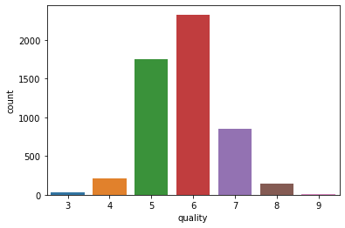

# to check the count of Red wine and white wine in the dataset  
sb.countplot(x='type',data=Winedata)

<AxesSubplot:xlabel='type', ylabel='count'>

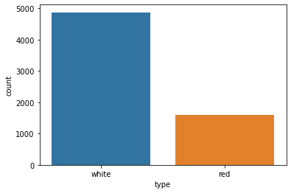

# plotting the data on the basis of type - univariate anlaysis  
sb.countplot(x = 'type', hue = 'quality', data = Winedata)

<AxesSubplot:xlabel='type', ylabel='count'>

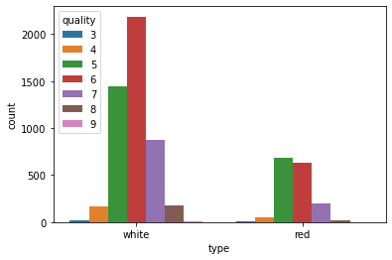

* Dataset contains more information about white wine than red wine**

sb.countplot(x='quality', data=Winedata)

<AxesSubplot:xlabel='quality', ylabel='count'>

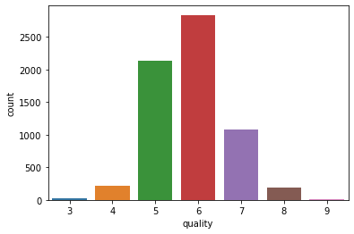

# plotting the data to check the quality   
sb.displot(x = Winedata['quality'], kde = True, color = 'green')

<seaborn.axisgrid.FacetGrid at 0x1fc52413280>

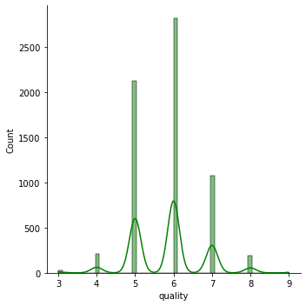

sb.barplot(x='quality',y='alcohol',data=Winedata)

<AxesSubplot:xlabel='quality', ylabel='alcohol'>

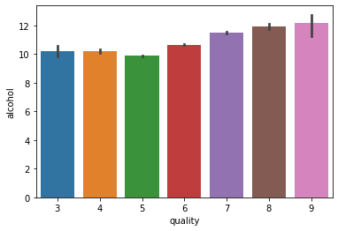

sb.barplot(x='quality',y='pH',data=Winedata)

<AxesSubplot:xlabel='quality', ylabel='pH'>

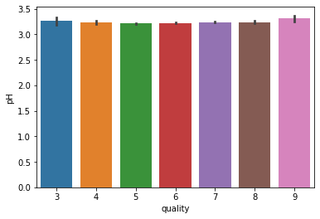

sb.barplot(x='quality',y='volatile acidity',data=Winedata)

<AxesSubplot:xlabel='quality', ylabel='volatile acidity'>

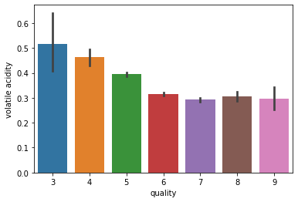

# As we can see, Mostly wine is of average quality 6

# > ANALYSIS OF QUALITY WITH OTHER VARIOUS FACTORS

# to check the quality of wine with all other attributes  
f, x = plt.subplots(4, 3, figsize = (25, 20))   
sb.regplot(x = Winedata['quality'], y = Winedata['fixed acidity'], ax = x[0, 0])  
sb.regplot(x = Winedata['quality'], y = Winedata['volatile acidity'], ax = x[0, 1])  
sb.regplot(x = Winedata['quality'], y = Winedata['citric acid'], ax = x[0, 2])  
sb.regplot(x = Winedata['quality'], y = Winedata['residual sugar'], ax = x[1, 0])  
sb.regplot(x = Winedata['quality'], y = Winedata['chlorides'], ax = x[1, 1])  
sb.regplot(x = Winedata['quality'], y = Winedata['free sulfur dioxide'], ax = x[1, 2])  
sb.regplot(x = Winedata['quality'], y = Winedata['total sulfur dioxide'], ax = x[2, 0])  
sb.regplot(x = Winedata['quality'], y = Winedata['sulphates'], ax = x[2, 1])  
sb.regplot(x = Winedata['quality'], y = Winedata['density'], ax = x[2, 2])  
sb.regplot(x = Winedata['quality'], y = Winedata['pH'], ax = x[3, 0])  
sb.regplot(x = Winedata['quality'], y = Winedata['alcohol'], ax = x[3, 1])

<AxesSubplot:xlabel='quality', ylabel='alcohol'>

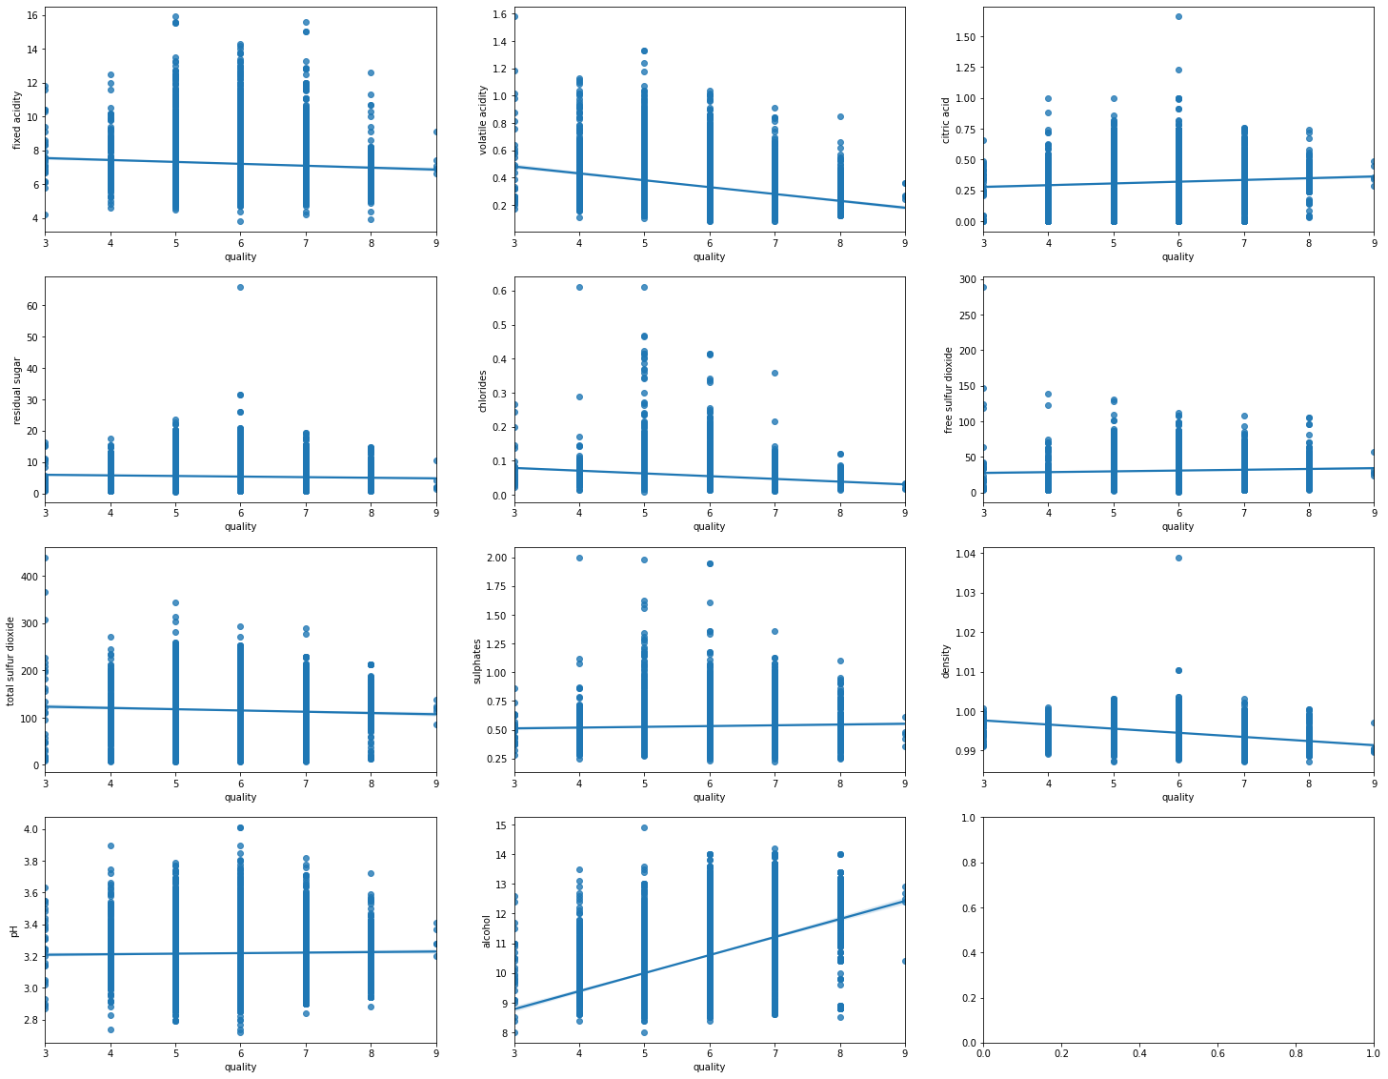

Observations from the above plot:

* Quality increases sharply with decrease in volatile acidity
* Quality increases with increase in citric acid
* Quality increases sharply with increase in alcohol

#to see the correlation  
Winedata.corr()

fixed acidity volatile acidity citric acid \  
fixed acidity 1.000000 0.216524 0.329252   
volatile acidity 0.216524 1.000000 -0.382750   
citric acid 0.329252 -0.382750 1.000000   
residual sugar -0.106084 -0.164438 0.146528   
chlorides 0.289903 0.368266 0.055266   
free sulfur dioxide -0.282025 -0.349784 0.130802   
total sulfur dioxide -0.328631 -0.401231 0.194231   
density 0.478920 0.308416 0.095824   
pH -0.269624 0.245329 -0.342648   
sulphates 0.307044 0.226537 0.062121   
alcohol -0.103657 -0.066781 -0.005124   
quality -0.049871 -0.143663 0.060059   
  
 residual sugar chlorides free sulfur dioxide \  
fixed acidity -0.106084 0.289903 -0.282025   
volatile acidity -0.164438 0.368266 -0.349784   
citric acid 0.146528 0.055266 0.130802   
residual sugar 1.000000 -0.123115 0.399579   
chlorides -0.123115 1.000000 -0.187312   
free sulfur dioxide 0.399579 -0.187312 1.000000   
total sulfur dioxide 0.487534 -0.270009 0.721308   
density 0.520194 0.372126 0.005827   
pH -0.233319 0.025963 -0.141368   
sulphates -0.174663 0.405771 -0.199005   
alcohol -0.305311 -0.270196 -0.169854   
quality -0.083970 -0.160716 0.011845   
  
 total sulfur dioxide density pH sulphates \  
fixed acidity -0.328631 0.478920 -0.269624 0.307044   
volatile acidity -0.401231 0.308416 0.245329 0.226537   
citric acid 0.194231 0.095824 -0.342648 0.062121   
residual sugar 0.487534 0.520194 -0.233319 -0.174663   
chlorides -0.270009 0.372126 0.025963 0.405771   
free sulfur dioxide 0.721308 0.005827 -0.141368 -0.199005   
total sulfur dioxide 1.000000 0.005974 -0.222003 -0.275389   
density 0.005974 1.000000 0.034979 0.283042   
pH -0.222003 0.034979 1.000000 0.166139   
sulphates -0.275389 0.283042 0.166139 1.000000   
alcohol -0.247779 -0.668950 0.096615 -0.019008   
quality -0.067750 -0.294350 0.048157 0.037557   
  
 alcohol quality   
fixed acidity -0.103657 -0.049871   
volatile acidity -0.066781 -0.143663   
citric acid -0.005124 0.060059   
residual sugar -0.305311 -0.083970   
chlorides -0.270196 -0.160716   
free sulfur dioxide -0.169854 0.011845   
total sulfur dioxide -0.247779 -0.067750   
density -0.668950 -0.294350   
pH 0.096615 0.048157   
sulphates -0.019008 0.037557   
alcohol 1.000000 0.418605   
quality 0.418605 1.000000

# plotting a heatmap to see the correlation of wine quality with other factors  
plt.figure(figsize = (15, 10))  
sb.heatmap(Winedata.corr(), annot = True,cmap='coolwarm')  
plt.show()

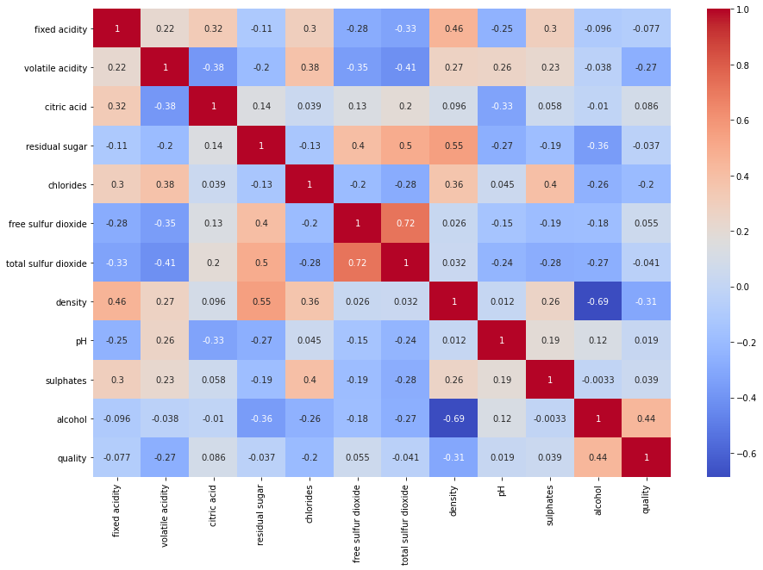

Observation:

1. total sulfur dioxide is highly correlated with free sulfur dioxide
2. fixed acidity is highly correlated with density and citric acid
3. alcohol is highly correlated with quality
4. citric acid is inversely correlated with pH and volatile acidity

#checking outliers using box plot  
Winedata.plot(kind="box",subplots=True,layout=(4,4),figsize=(15,15))

fixed acidity AxesSubplot(0.125,0.71587;0.168478x0.16413)  
volatile acidity AxesSubplot(0.327174,0.71587;0.168478x0.16413)  
citric acid AxesSubplot(0.529348,0.71587;0.168478x0.16413)  
residual sugar AxesSubplot(0.731522,0.71587;0.168478x0.16413)  
chlorides AxesSubplot(0.125,0.518913;0.168478x0.16413)  
free sulfur dioxide AxesSubplot(0.327174,0.518913;0.168478x0.16413)  
total sulfur dioxide AxesSubplot(0.529348,0.518913;0.168478x0.16413)  
density AxesSubplot(0.731522,0.518913;0.168478x0.16413)  
pH AxesSubplot(0.125,0.321957;0.168478x0.16413)  
sulphates AxesSubplot(0.327174,0.321957;0.168478x0.16413)  
alcohol AxesSubplot(0.529348,0.321957;0.168478x0.16413)  
quality AxesSubplot(0.731522,0.321957;0.168478x0.16413)  
dtype: object

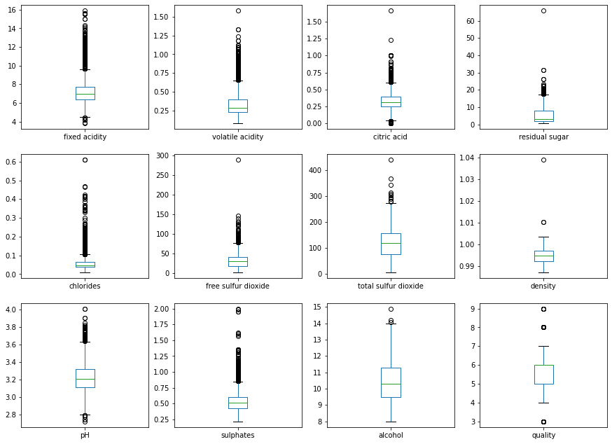

Observation from box plot:

“fixed.acidity” is a measure of inside liquid concentration. The histogram a right-skewed distributed with some outliers located at right side. The most frequent values are between 7-8. “volatile.acidity” is measure of acidity above-surface of liquid. The histogram is right-skewed distributed with some outliers located at right side. The most frequent values are between 0.4-0.6. “citric.acid” is right-skewed distributed with some outliers located at very right side. The most frequent values 0. It’s also interesting a lot of wine have citric.acid = 0 “residual.sugar” is right-skewed distributed “chlorides” is right-skewed distributed The most frequent values are between 0.05-0.1 “free.sulfur.dioxide” is right-skewed distributed “sulphates” is a right-skewed distributed

# Data Modeling:

# importing all the required libraries for machine learning models  
  
import sklearn  
from sklearn.preprocessing import StandardScaler  
from sklearn.model_selection import train_test_split, GridSearchCV, cross_val_score  
from sklearn.metrics import confusion_matrix  
from sklearn.metrics import classification_report  
  
from sklearn.svm import SVC  
from sklearn.tree import DecisionTreeClassifier  
from sklearn.linear_model import LogisticRegression  
from sklearn.naive_bayes import GaussianNB  
from sklearn.ensemble import RandomForestClassifier  
from sklearn.metrics import accuracy_score

# let's categorize the quality column to apply classification model  
# 1 is good qualit y and 0 is bad quality  
Winedata['quality']=Winedata['quality'].apply (lambda x:1 if x > 6 else 0 )  
Winedata.head()

type fixed acidity volatile acidity citric acid residual sugar \  
0 white 7.0 0.27 0.36 20.7   
1 white 6.3 0.30 0.34 1.6   
2 white 8.1 0.28 0.40 6.9   
3 white 7.2 0.23 0.32 8.5   
4 white 7.2 0.23 0.32 8.5   
  
 chlorides free sulfur dioxide total sulfur dioxide density pH \  
0 0.045 45.0 170.0 1.0010 3.00   
1 0.049 14.0 132.0 0.9940 3.30   
2 0.050 30.0 97.0 0.9951 3.26   
3 0.058 47.0 186.0 0.9956 3.19   
4 0.058 47.0 186.0 0.9956 3.19   
  
 sulphates alcohol quality   
0 0.45 8.8 0   
1 0.49 9.5 0   
2 0.44 10.1 0   
3 0.40 9.9 0   
4 0.40 9.9 0

Winedata.sample(10)

type fixed acidity volatile acidity citric acid residual sugar \  
4945 red 8.7 0.290 0.52 1.60   
912 white 6.3 0.340 0.19 5.80   
548 white 6.5 0.180 0.31 1.70   
350 white 6.3 0.120 0.36 2.10   
5949 red 8.5 0.460 0.59 1.40   
1127 white 6.4 0.125 0.29 5.85   
1140 white 8.5 0.160 0.33 1.00   
4395 white 6.6 0.240 0.22 12.30   
4040 white 6.3 0.240 0.29 1.60   
15 white 6.6 0.170 0.38 1.50   
  
 chlorides free sulfur dioxide total sulfur dioxide density pH \  
4945 0.113 12.0 37.0 0.99690 3.25   
912 0.041 22.0 145.0 0.99430 3.15   
548 0.044 30.0 127.0 0.99280 3.49   
350 0.044 47.0 146.0 0.99140 3.27   
5949 0.414 16.0 45.0 0.99702 3.03   
1127 0.042 24.0 99.0 0.99200 3.23   
1140 0.076 17.0 57.0 0.99210 3.14   
4395 0.051 35.0 146.0 0.99676 3.10   
4040 0.052 48.0 185.0 0.99340 3.21   
15 0.032 28.0 112.0 0.99140 3.25   
  
 sulphates alcohol quality   
4945 0.58 9.5 0   
912 0.63 9.9 0   
548 0.50 10.2 1   
350 0.74 11.4 1   
5949 1.34 9.2 0   
1127 0.32 12.0 1   
1140 0.46 10.6 0   
4395 0.67 9.4 0   
4040 0.50 9.4 0   
15 0.55 11.4 1

x.head()

fixed acidity volatile acidity citric acid residual sugar chlorides \  
0 7.0 0.27 0.36 20.7 0.045   
1 6.3 0.30 0.34 1.6 0.049   
2 8.1 0.28 0.40 6.9 0.050   
3 7.2 0.23 0.32 8.5 0.058   
6 6.2 0.32 0.16 7.0 0.045   
  
 free sulfur dioxide total sulfur dioxide density pH sulphates \  
0 45.0 170.0 1.0010 3.00 0.45   
1 14.0 132.0 0.9940 3.30 0.49   
2 30.0 97.0 0.9951 3.26 0.44   
3 47.0 186.0 0.9956 3.19 0.40   
6 30.0 136.0 0.9949 3.18 0.47   
  
 alcohol   
0 8.8   
1 9.5   
2 10.1   
3 9.9   
6 9.6

y.head()

0 6  
1 6  
2 6  
3 6  
6 6  
Name: quality, dtype: int64

# divinding dataset into independent and dependent variables  
#input split - DISCRETE(X) AND CATEGORICAL VARIABLE(Y)  
  
x=Winedata.drop(['quality','type'], axis = 1)  
y=Winedata['quality']

x.shape

(5329, 11)

Splitting the data into training and testing model

from sklearn.model_selection import train_test_split

#model splitting with 30% test data and 70% train dataset  
  
  
x_train,x_test,y_train,y_test = train_test_split(x,y,test_size=0.3,random_state=10)

#Feature scaling - standardize the data to same scale  
sc=StandardScaler()  
x_train=sc.fit_transform(x_train)  
x_test=sc.fit_transform(x_test)

x_train

array([[-6.09071343e-01, -4.95364455e-01, 5.43707332e-01, ...,  
 -8.37121346e-01, 2.89828723e-02, -3.93493362e-01],  
 [-3.09907999e-01, -7.34440057e-01, 2.52161486e-03, ...,  
 -1.51668423e-01, 2.25858629e-01, 1.96222690e-01],  
 [-6.09071343e-01, -5.55133355e-01, -2.68071244e-01, ...,  
 -8.37121346e-01, 2.91483881e-01, 1.88112569e+00],  
 ...,  
 [-6.09071343e-01, -5.55133355e-01, 2.84374663e+00, ...,  
 -8.93545212e-02, -7.58520155e-01, -1.15169971e+00],  
 [ 4.38000360e-01, 3.38961408e+00, -1.68868375e+00, ...,  
 1.78006254e+00, -6.92894902e-01, 1.11977539e-01],  
 [ 7.37163704e-01, -7.34440057e-01, 1.15254126e+00, ...,  
 -1.27331866e+00, -1.34914742e+00, 2.77323892e-02]])

x_test.shape

(1599, 11)

x_train.shape

(3730, 11)

# Machine Learning Supervised model - classification method

#classify function - classification methods/models  
def classify(model, x, y):  
 x_train,x_test,y_train,y_test = train_test_split(x,y,test_size=0.3,random_state=42)  
 #train the model  
 model.fit(x_train,y_train)  
 print("Accuracy:", model.score(x_test,y_test) * 100)

## model 1 - Random forest  
  
reg=RandomForestClassifier(n_estimators=80)  
  
reg.fit(x_train,y_train)  
y_pred=reg.predict(x_test)  
classify(reg,x,y)

Accuracy: 88.03506962351729

cm=confusion_matrix(y_test,y_pred)  
print(cm)  
  
plt.matshow(cm)

[[1506 60]  
 [ 162 211]]

<matplotlib.image.AxesImage at 0x1fc524ec850>

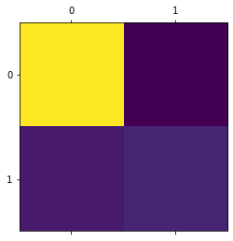

# model 2 - Decision tree  
  
DT=DecisionTreeClassifier()  
classify(DT,x,y)

Accuracy: 82.98091799896854

### model 3 Naive bayes   
nb = GaussianNB()  
nb.fit(x_train,y_train)  
nb_predict=nb.predict(x_test)

#print confusion matrix and accuracy score  
nb_conf_matrix = confusion_matrix(y_test, nb_predict)  
nb_acc_score = accuracy_score(y_test, nb_predict)  
print(nb_conf_matrix)  
print(nb_acc_score*100)

[[1223 343]  
 [ 138 235]]  
75.19339865910263

### model 4- lOGISTIC REGRESSION MODEL  
  
#creating a instance for LR  
LRmodel=LogisticRegression()  
  
#fitting the model with training data  
LRmodel=LogisticRegression().fit(x_train,y_train)  
  
#predicting the model with test data  
pred_LR=LRmodel.predict(x_test)  
  
#evalutaing the model  
cm2=confusion_matrix(y_test,pred_LR)  
print(cm2)  
#plotting the CM  
ax2=sb.heatmap(cm2,annot=True)  
plt.show()

[[1495 71]  
 [ 258 115]]

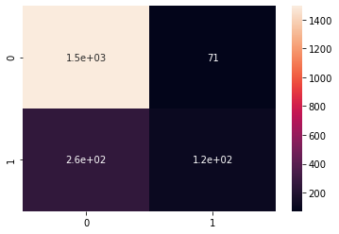

#evaluating the MODEL predictions  
classification_report(y_test,pred_LR)

' precision recall f1-score support\n\n 0 0.85 0.95 0.90 1566\n 1 0.62 0.31 0.41 373\n\n accuracy 0.83 1939\n macro avg 0.74 0.63 0.66 1939\nweighted avg 0.81 0.83 0.81 1939\n'

#evaluating the predictions  
accuracy_score(y_test,pred_LR)  
accuracy_score(y_test,pred_LR)*100

83.03249097472924

# RESULT:

1. The data was downloaded from UCI Machine Learning Repository.
2. The datasets contains 25% red and 75 % white variants of the Portuguese "Vinho Verde" wine.
3. Mostly wine is of the average quality 6. There are low poor and excellent quality wine
4. Quality increases sharply with decrease in volatile acidity
5. Quality increases with increase in citric acid
6. Quality increases sharply with increase in alcohol. Alcohol is highly correlated with quality
7. total sulfur dioxide is highly correlated with free sulfur dioxide
8. fixed acidity is highly correlated with density and citric acid
9. citric acid is inversely correlated with pH and volatile acidity
10. We used 4 classification machine learning algorithms for the model prediction
11. Random Forest classifier gives the highest accuracy of 88%
12. Logistic Regression gives the accuracy of 83%
13. Decision Tree gives the accuracy of 82.7%
14. Naive Bayes gives 75% accuracy of the model
15. We have also used feature scaling for standardizing the data to the same scale.
16. We have viewed the results using classification report and the confusion matrix.

Wine Recommendation:

Château Lafite Rothschild (Bordeaux, France) Domaine de la Romanée-Conti (Burgundy, France) Domaine Etienne Guigal (Rhone, France)